**Given an IP address range of 192.168.1.0/24, divide the network into 4 subnets.**

**Task: Manually calculate the new subnet mask and the range of valid IP addresses for each subnet.**

**Assign IP addresses from these subnets to devices in Cisco Packet Tracer and verify connectivity using ping between them.**

We need 4 subnets, since 2 squared is 4, I'll borrow 2 bits from the host portion of the original /24 network.

The original /24 means 24 bits were for the network. By adding the 2 borrowed bits, I get a new /26 network. The new subnet mask is 255.255.255.192.

I subtract the last octet of the new subnet mask (192) from 256.

256 – 192 = 64

**Subnet 1:** Starting with the original network address, 192.168.1.0/26.

The IP range is 192.168.1.1 to 192.168.1.62.

The broadcast address is 192.168.1.63.

**Subnet 2:** Adding 64, the next network address is 192.168.1.64/26.

The IP range is 192.168.1.65 to 192.168.1.126.

The broadcast address is 192.168.1.127.

**Subnet 3:** Adding another 64, the network address is 192.168.1.128/26.

The IP range is 192.168.1.129 to 192.168.1.190.

The broadcast address is 192.168.1.191.

**Subnet 4:** Adding 64 again, the network address is 192.168.1.192/26.

The IP range is 192.168.1.193 to 192.168.1.254.

The broadcast address is 192.168.1.255.

**Setting up packet tracer:**

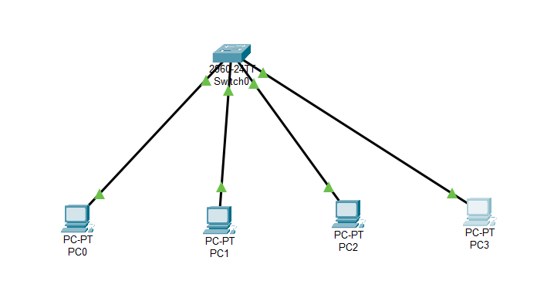

**Pinging other 3 PCs from PC0:**

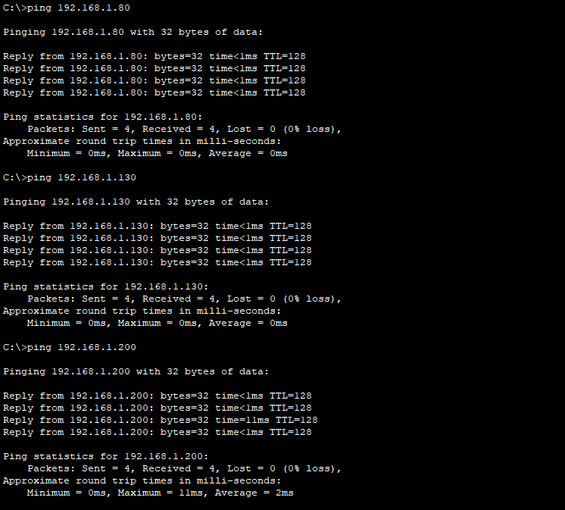

**The ping is successful, so the network is properly configured, and all devices can communicate as expected.**